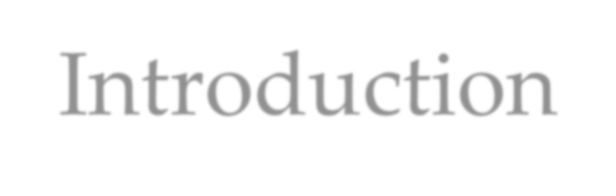

Introduction

 Hyderabad is the one of commercial capital of India.

 Hyderabad developed a highly diversified infrastructure.

 With its diverse society, comes diverse infrastructure which decides the quality of living.

 When one moves to a new city like Hyderabad, is where to find a

good area to build and grow prosperously.

 The purpose is to help people in exploring better facilities around their neighborhood.

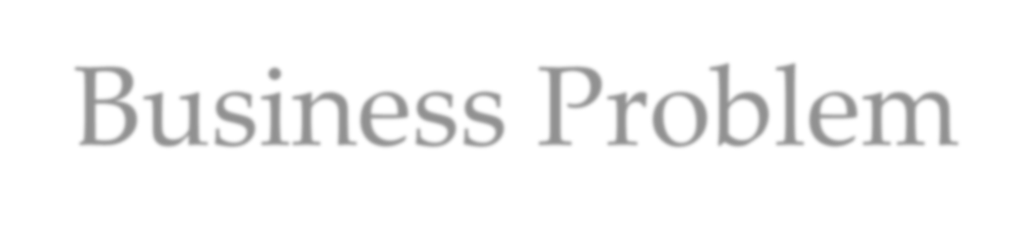

Business Problem

The questions I aim to answer in this project are the following:

1. *List and visualize all major parts of Hyderabad City with top existing infrastructure.*
2. *What are the best locations in Hyderabad as per infrastructure?*
3. *Which areas have the potential for the development of infrastructure of different kinds?*
4. *Which all areas lack the infrastructure facilities?*
5. *What is the best place to stay within a city for all vital infrastructure facilities?*



 For this project we need the following data:

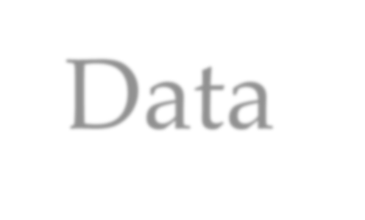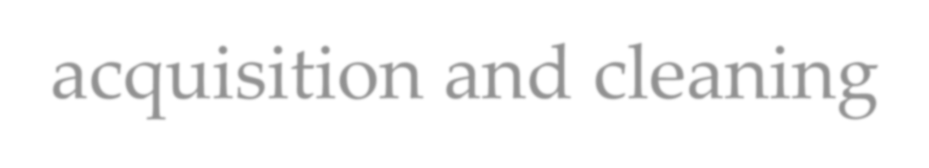

Data acquisition and cleaning

1. Hyderabad Pincode ( Scraped from web source)
2. Hyderabad City data ( Geospace Data on Mumbai Pincode)
3. Different infrastructures in each neighborhood of Hyderabad City data (Foursquare API)



# Methodology

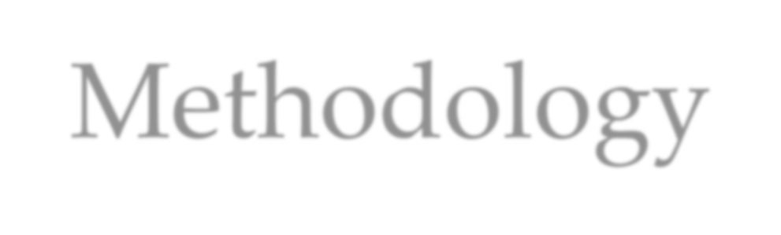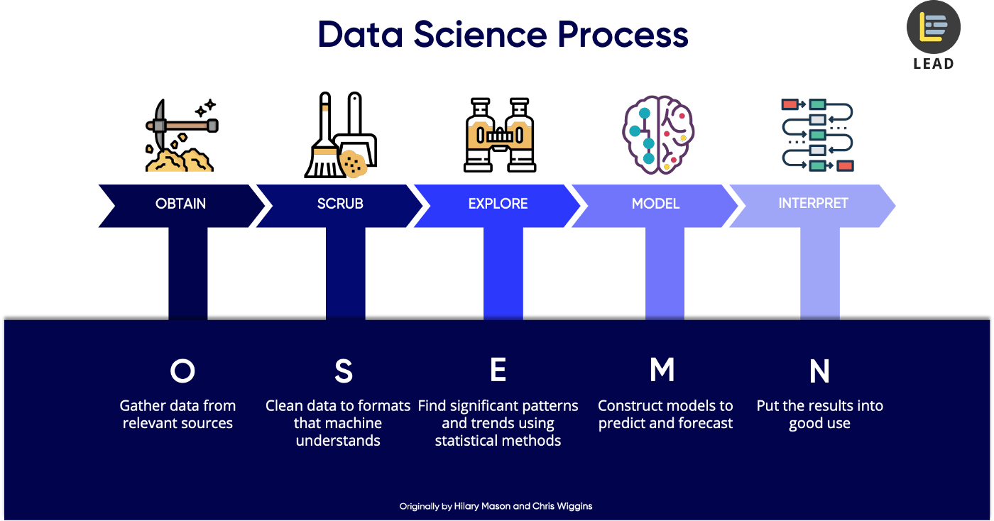

Credit is provided below the image

cluster 0.



Recommendation

 Recommendation from Clustering :

 Cluster 1 with little to no competition - To open new infrastructures.

 Cluster 2 with moderate competition and supporting adequate no. of infrastructures – Ideal place to live prosperously and open unique infrastructures.

 Cluster 0 which already has a high concentration of infrastructures. – To settle in city and tough market to open new infrastructures.

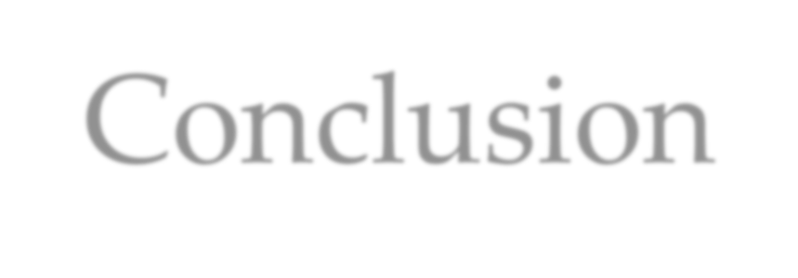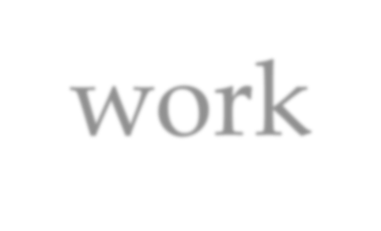

Conclusion and future work

 This project made use of the free Sandbox Tier Account of Foursquare API - Limitations as to the number of API calls and results returned.

 Finding of these project will help relevant stakeholders i.e. **business developers** regarding the best locations to open a new infrastructure.

 The project also provides **visitors and immigrants** to the city regarding new postal office areas for growth and

